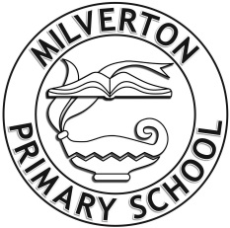
Milverton Primary School
Induction Folder

Our School Vision and Aims

Milverton Primary School Vision and Aims outline the school we aspire to be. Children who attend Milverton begin their educational journey with us. During the time we spend with them, we hope to enable the journey as written in the statements below. The Primary School years should be a magical time, giving children the secure moral, personal, social and educational foundations with which to move onwards.

Milverton Primary School

Where the Journey begins…

- A journey through a memorable curriculum to develop confident, creative and curious minds
- A journey full of challenge and exciting experiences that develops resilience, strength and determination
- A journey as a part of a nurturing, caring community that encourages children to enjoy life and love learning
- A journey that guides children to celebrate individuality, to appreciate differences and to respect others
- A journey that empowers children to explore and become free thinking individuals
- A journey that allows children to mature into empathetic people, caring for themselves, for others and for the world around them
- A journey that prepares children to find success in whatever they choose to do
- A journey that inspires children to reach for new horizons

